STAUNTON PARISH COUNCIL
Minutes of meeting held on Tuesday 14th January 2020
Venue: Corse and Staunton Village Hall Annexe
Time: 7:30pm
Present: Councillors; J. Millar, D. Williams, B. Allen, A. Fardon, E. Bradbury, D. Peach, M. Fuller, R. Hall (Corse Parish Council Representative), G. Millar (Clerk) and 16 Parishioners.
- Chairman’s Welcome
Cllr Millar welcomed all present including Staunton Parish Council’s invited speakers, representatives from Two Rivers Housing.

- Receive Apologies
Apologies were received from County Councillor Philip Burford, District Councillor Brian Lewis and Parishioner Irene Carroll.

- Declarations of Interest
None declared.

- To confirm the minutes of the previous bi-monthly meeting held on Tuesday 12th November 2019
The minutes of the previous bi-monthly meeting held on Tuesday 12th November 2019 were proposed by Cllr Williams and seconded by Cllr Bradbury to be accepted as a true record.

- County Councillor Report
No report given due to County Councillor Will Windsor-Clive’s absence.

- District Councillor Report
No report given due to the absence of both District Councillor Philip Burford and District Councillor Brian Lewis.

- Two Rivers
Cllr Millar introduced the Two Rivers Housing representatives who provide background information regarding the planned redevelopment of Johnstone Close. This is due to the current properties reaching their maximum potential size and location wise which no longer falls in line with the requirements of residents.

Whilst some have already moved, a number of residents still remain in their properties. Reassurance was given to those residents who voiced concern over the project that no residents will be forcibly removed from their properties. Two Rivers Housing is working closely with all residents to ensure their move fits the needs and requirements of those involved. Residents will also be given the option to move back to Staunton once the redevelopment is complete. Consultations will be arranged and held with residents at all stages in the process, with Two Rivers Housing also agreeing to attend future meetings of Staunton Parish Council with any updates.
Cllr Allen also stated that Staunton Parish Council is aware of the ongoing road safety issues in the village and Councillors are doing all they can to rectify the issues. However, it was suggested that District Councillors and our County Councillor be contacted regarding any further measures that can be taken and whether anything can also be done to improve the infrastructure issues also apparent within Staunton.

9. Quiz
Cllr Fuller stated that the next fundraising quiz night will be held on Wednesday 29th February 2020, with a request for any funds raised to be shared with Cllr Fuller in the lead up to his fundraising efforts in aid of Nordoff Robbins, Teenage Cancer Trust and ChildLine. All Councillors were in agreement with this request. A further fundraising quiz night has been booked for Wednesday 25th March 2020, all who wish to attend need to pre-book tables of 4 or 6 with The Swan.

11.Rural Watch Coordinator and Neighbourhood Watch Scheme
Cllr Millar introduced the item, reminding all of the Neighbourhood Scheme in operation. However, stated that we need further representation in Staunton and Corse. Cllr Fuller mentioned Phil Waring, Neighbourhood Watch Coordinator who is looking to further representation of Staunton and Corse as well as other neighbouring Villages. Staunton Parish Council to invite Phil Waring to next full meeting of the Council on Tuesday 10th March 2020 to provide further information regarding this initiative.

8.2020/21 Budget
After all Councillors consulted the proposed 2020/21 budget it was approved by the full Council. This was proposed by Cllr Williams and seconded by Cllr Allen.

10.Culvert and Drainage Ditches
Cllr Millar introduced the item put forward by District Councillor Brian Lewis in his absence, which expressed concern for the culvert and drainage systems throughout Staunton. Cllr Allen stated that Ledbury Road Crescent was a particular issue, reminding all that ditches running along residents’ properties are their responsibility. Cllr Millar circulated a leaflet regarding Riparian Rights, with more to be sourced and circulated around residents and village noticeboards. Cllr Peach to also include this as an item for information within upcoming Parish Magazine newsletter. Cllr Williams has also agreed to add culverts and ditches to his Councillor responsibilities going forward.

12.St James Church Funding Request
Cllr Millar explained to all that a funding request has been received to allow for adaption of access to St James’ Church and its’ grounds for those with mobility issues. The item was then opened up for discussion and further information provided due to the high cost of the project. This is due to the ramp levelling requirements. Following a discussion it was agreed that due to restricted availability of precept funds, it be established what other funding avenues have been explored before Staunton Parish Council discusses any donation.

13.Mobile Library
Cllr Millar told all that the new Library service will now be held in the Annexe of Corse and Staunton Village Hall on the first Tuesday of every month between 10am-1pm, starting on Tuesday 3rd March 2020.

14.Staunton and Corse Patients Group
Cllr Peach stated that there has been no meeting to report the minutes of, however there have been a number of members leave the group including the chairman Sue Knox who has now been replaced by Malcolm Harley. Cllr Peach also strongly encouraged younger members of the community to join, with contact to be made with Hartpury College regarding this following a member of teaching staff from the college attending Staunton Parish Council’s meeting.

Staunton and Corse Surgery are to be launching a new website soon encouraging patients to contact the surgery via email.

15. Finance

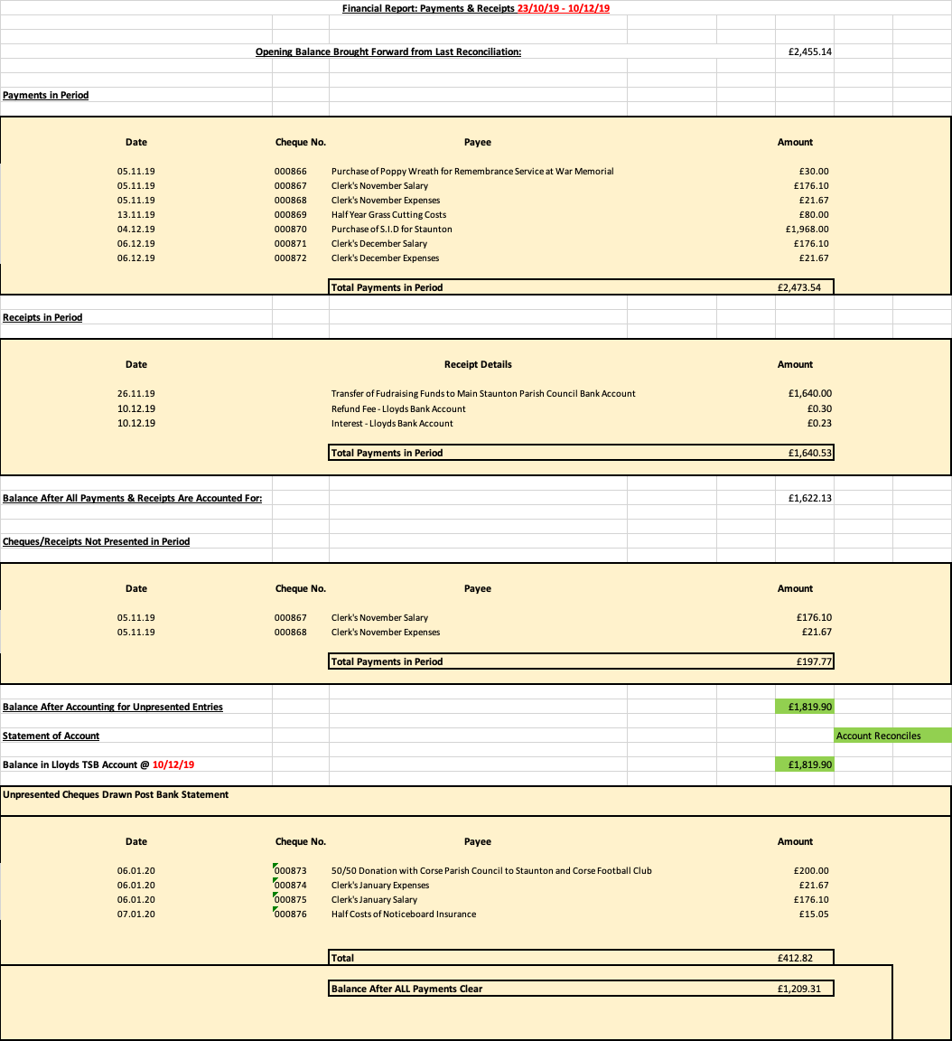

Reference Number  16.Planning | Applicant’s Address | PC Comment | Decision
P1431/19/FUL | Erection of an agricultural building with associated works – El Minzah, Moat Lane, Staunton, Gloucestershire, GL19 3QG | NO OBJECTION | GRANTED PERMISSION
P1468/19/FUL | Change of use of land for equestrian purposes, construction of manege and erection of stable block with associated hardstanding – Land Adjoining The Cottage, Prince Crescent, Staunton, Gloucestershire, GL19 3RF | NO OBJECTION | GRANTED PERMISSION
P1500/19/FUL | Erection of a single storey extension with associated works – Ellis Farm, Sladbrook Lane, Staunton, Gloucestershire, GL19 3QP | NO OBJECTION | GRANTED PERMISSION
P1633/19/FUL | Erection of an outbuilding to be used as additional accommodation to be occupied incidental to the enjoyment of The Willows as a single-family dwelling house - The Willows, Ledbury Road Crescent, Staunton, Gloucestershire, GL19 3QB | OBJECTION | GRANTED PERMISSION
P1844/19/FUL | Erection of a single storey rear extension including the installation of No.2 roof lights to existing roof and raising of existing flat roof to existing rear extension and installation of new bedroom window - The Willows, Ledbury Road Crescent, Staunton, Gloucestershire, GL19 3QB | NO OBJECTION | PENDING CONSIDERATION

17.Any other business
Cllr Fardon requested that the Speed Indicator Device on Ledbury Road to be fixed. Cllr Millar to follow this up as Staunton Parish Council is not responsible for this particular device. Cllr Fardon also encouraged all to buy a copy of the Corse & Staunton of yesteryear - Vol.2 - with around 200 copies still available.
18. Public Participation
No matters were raised.

The meeting finished at 9:23pm
Signed: Date:

