STAUNTON PARISH COUNCIL
Minutes of meeting held on Tuesday 10th March 2020
Venue: Corse and Staunton Village Hall Annexe
Time: 7:30pm
Present: Councillors; J. Millar, D. Williams, B. Allen, A. Fardon, M. Fuller, B. Lewis (District Councillor), P. Burford (District Councillor and Corse Parish Council Representative), G. Millar (Clerk) and 3 Parishioners.
- Chairman’s Welcome
Cllr Millar welcomed all present including invited speaker Phil Waring, Neighbourhood Watch Coordinator.

- Receive Apologies
Apologies were received from Cllr Peach and Cllr Bradbury.

- Declarations of Interest
None declared.

- To confirm the minutes of the previous bi-monthly meeting held on Tuesday 14th January 2020
The minutes of the previous bi-monthly meeting held on Tuesday 14th January 2020 were proposed by Cllr Allen and seconded by Cllr Williams to be accepted as a true record.

- County Councillor Report
No report given due to County Councillor Will Windsor-Clive’s absence.

- District Councillor Report
District Councillor, Philip Burford reported that the District Council’s budget for 2020/2021 has now been approved and that they have a £1.2m deficit. There is also a biodiversity emergency which has been raised by a member of the Green Party. Climate, housing and age-related emergencies are also to be dealt with.

It was also noted that the current business rate relief applicable to village halls is to be lifted by the District Council.

- District Councillor Report
District Councillor, Brian Lewis reported that planning appeal ‘APP/P1615/W/19/3227891’ for the land on Straight Lane was heard at an informal hearing and sustainability, views and facilities issues were raised. A decision on this appeal is yet to be reached.

The importance of riparian rights within the village was also highlighted. Cllr Millar noted that Staunton Parish Council has obtained leaflets for distribution to provide further information. The flooding department from Forest of Dean District Council has also offered to attend a future meeting of the Council to provide further guidance and information.

- Neighbourhood Watch Scheme
Cllr Fuller introduced Phil Waring, Neighbourhood Watch Coordinator regarding the development of a Neighbourhood Watch scheme that encompasses multiple villages within the local area. This allows for further transparency and distribution of accurate information, eradicating hearsay and unnecessary fear.

In June, during Neighbourhood Watch week there will be a leaflet drop in Redmarley to encourage all to join a Neighbourhood Watch scheme operating within the parish. Currently Derrick Hall is the operator for Corse, and Cllr Fardon for Staunton.
Cllr Fuller suggested establishing additional conduits for the scheme, with Staunton Parish Council to identify those interested.

Cllr Fuller then updated all on his current works to improve the flooding issues along the A417.
District Councillor, Brian Lewis agreed to follow up Cllr Fuller’s correspondence with Mark Harper MP regarding the current flooding issues in the local area.
District Councillor, Philip Burford noted the Highways Plan for Gloucestershire which runs until 2050 that includes works at Maisemore to be completed and the availability of funds for those affected by flooding.

- Strategic Housing & Economic Land Availability Assessment
Cllr Millar introduced the item and stated that all submissions of sites for further development must be made by Sunday 29th March. Cllr Millar then opened the item for discussion; however, no suggestions were raised.

- Quiz
Cllr Allen announced that the next quiz night will be held on Wednesday 25th March with the chance to win plenty of raffle prizes. Cllr Millar also thanked Cllr Fuller for writing the questions for the event.

- Culvert and Drainage Ditches
It was agreed by all Councillors that this agenda item shall be raised annually in order to continually assess any issues. Cllr Williams also to draft a letter to be distributed alongside information leaflets regarding Riparian Rights to those concerned.

- Mobile Library
Cllr Millar stated that the first mobile library service was a great success with a great number in attendance. Further details regarding this service can be found on Staunton Parish Council’s website: www.stauntonandcorse.co.uk .

- VE day 75 Commemoration – 8th - 10th May 2020
Cllr Williams to lead preparations for Staunton Parish Council’s involvement in the VE day Commemoration, with a venue to be decided. It was agreed by all Staunton Parish Councillors, that this should be a joint effort with Corse Parish Council, however this is still to be arranged given the current restrictions surrounding the Coronavirus pandemic.

- Staunton and Corse Patients Group
Chairman of Staunton and Corse Patients Group, Malcolm Harley encouraged younger members of the community to join. Cllr Millar then read report in Cllr Peach’s absence.
Staff News: Maggie Etheridge has retired from the practice and her replacement is Jennifer Odell; she comes from an emergency care background and will be taking up her role as manager/practioner nurse on the 20th April. In the meantime Karina Blackwell will be ‘filling the gap’ by working some extra hours, as well as being supported by locum nurses.
It has also been announced that Dr Kingcombe and her husband have had twins.
Practice Website: The new website, run by Silicone, has now become ‘live’. The new website looks very different, but patients still ‘log in’ for services such as repeat prescriptions and appointments using their current details via a link to the usual EMISS Patient Access site. There is also a facility to contact the Practice by email, but note that this is not to be used to make an appointment or an urgent medical enquiry.
Coronavirus: This is an evolving crisis and advice will be updated as and when it is issued. Currently, the recommendation is to stay at home, avoid contact with others and call NHS 111 if you have a cough, high temperature or shortness of breath after being in contact with someone with a confirmed case of Coronavirus. Or if you’ve been in mainland China, Hong Kong, Japan, Macau, Malaysia, Republic of Korea, Singapore, Taiwan, Thailand, Northern Italy, Vietnam or Cambodia and have a cough, high temperature or shortness of breath within 2 weeks of returning. Do not go to your surgery. General hygiene advice applies: catch sneezes and coughs in a tissue, bin the tissue and then wash your hands. Remember to carry tissues with you and you can also buy antibacterial hand cleanser to carry in your bag or pocket if you wish. If you are an international traveller please see the following websites for up to date detailed information as it changes: https://www.nhs.uk/conditions/coronavirus-covid-19/ and https://www.gov.uk/guidance/wuhan- novel-coronavirus-information-for-the-public.
Flu Vaccinations: Both the over and under 65 age group vaccines are still available; if you have not yet had your flu vaccination, appointments can be made until the end of March.
PPG Membership: Sue Knox has stepped down as Chair and retired from the group. We all wish her well and thank her for all her hard work and the effort that she has put in over the past three years. Malcolm Harley takes over as Chairman.
The group urgently needs new members and invites anyone interested in joining the group to contact Malcolm Harley or the Staunton and Corse Practice Manager for details. There is also a PPG link via the Practice website where you can register for information. We meet once every two months on a Wednesday lunch time at the Staunton and Corse Surgery.
Donald Peach on behalf of Staunton and Corse Patient Participation Group.
Note: The Patient Participation Group (PPG) meets bi-monthly and acts as a ‘go between’ for patients and the Surgery. Parishioners should feel free to contact the PPG if they have questions or concerns about access to the Practice and how it is run. Contact is via the Suggestion Box in the foyer at the surgery and a new email contact is being arranged. All queries are passed to the Surgery Manager, Sarah Bryant, who will decide how best to deal with individual issues. However, we should point out that any personal health issues MUST be addressed directly to the Surgery staff or your doctor and not the PPG.
- Internal Finance Check
Cllr Millar noted in Cllr Bradbury’s absence that the bi-annual internal finance check of Staunton Parish Council’s financial records had been successfully conducted with no issues raised.

16. Finance

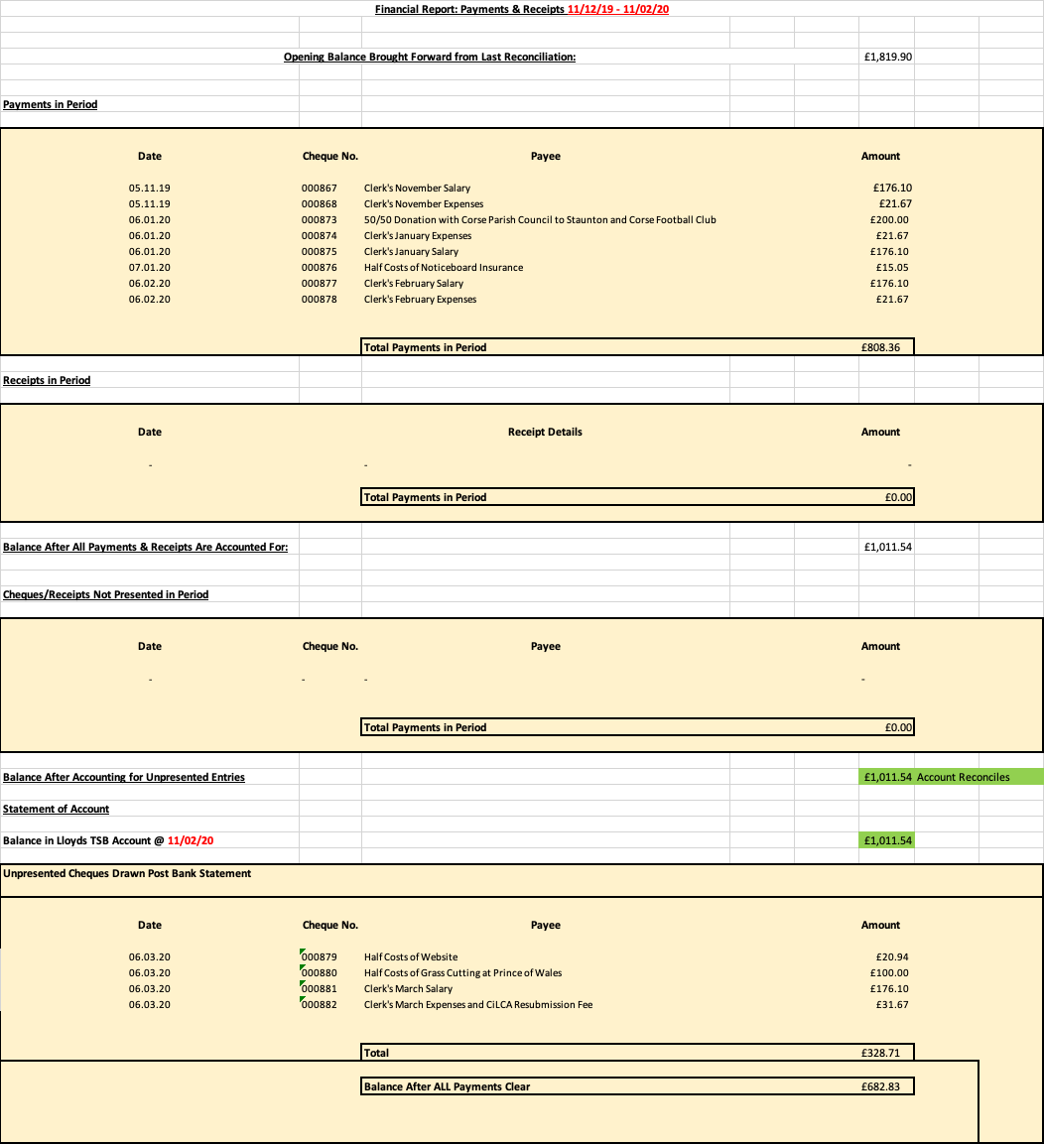
- Planning
Reference Number | Applicant’s Address | PC Comment | Decision
P1844/19/FUL | Erection of a single storey rear extension including the installation of No.2 roof lights to existing roof and raising of existing flat roof to existing rear extension and installation of new bedroom window - The Willows, Ledbury Road Crescent, Staunton, Gloucestershire, GL19 3QB | NO OBJECTION | GRANTED PERMISSION
P0049/20/TCA | Reduction of two Silver Birch, a Hawthorn and a Crab Apple by 30% each - 8 Cullingham Close, Staunton, Gloucestershire, GL19 3RX | NO OBJECTION | GRANTED PERMISSION

- Any Other Business
Cllr Fardon noted two accidents have occurred recently along the A417 which were both speed related. Works are underway to fix the broken speed sign, and Cllr Allen explained the current situation regarding Staunton Parish Council’s recent purchase of a new speed indicator device.

A number of footpath related issues were raised, with Cllr Williams to highlight them again to Suzanne Hopes, Public Rights of Way Officer at Gloucestershire County Council.

Cllr Millar also read Malcolm Harley’s most recent letter regarding the St. James’ Church funding request, with Councillors to further consider this.

- Public Participation
No matters were raised.

The meeting finished at 9:00pm
Signed: Date:

