GLOUCESTERSHIRE LIBERAL DEMOCRATS ANNUAL REPORT
The Liberal Democrats campaigned successfully in May 2025, winning 27 of the 55 seats at Gloucestershire County Council and formed a minority administration. We set to work immediately to implement the key pledges in our manifesto and you can find here an update on the progress we have made so far. We still have lots to do and are excited about carrying on with this work over the next year.
Local Government Reorganisation (LGR) and Devolution
We are working carefully with each of the district councils to ensure that the transition to unitary authority(ies) is as smooth as possible. Together we have set up a programme board with numerous workstreams covering people, digital, governance, property and more. This will help ensure the county is ready regardless of which option Government selects.
We have expressed our interest in joining the West of England combined authority (WECA). This is the best fit for Gloucestershire as it has the strongest score across all assessment criteria including economic alignment and existing partnerships.
We are fully committed to ensuring the best future for Gloucestershire and will continue to work tirelessly to build partnerships and prepare for LGR and Devolution.

Finance, Assets & Transformation
We have carefully analysed all council spending to identify where savings and efficiencies can be made in order to open more funding for the areas that matter most to our residents.
We identified over £32 million in savings which were missed by the previous Conservative administration, allowing us to pass an ambitious budget focused on investment in areas that matter most such as highways, education and care. This is despite the Governments poorly named ‘fair’ funding review which hugely reduced the funding we get from Government.
We continued our commitment to a fair, open council through our Commercial Strategy. This overhauls GCC’s commercial operations, procurement and income generation to ensure we are business like in our actions and as efficient as possible.
We are working hard to transform the way this council works and ensure we are getting the most out of each and every pound spent.

Highways
We are committed to fixing our roads
The adverse weather this year has led to an increase in potholes and decrease in road quality across the entire country. However, we remain committed to tackling these issues and improving conditions across the county.
We are undertaking a highways peer review to ensure the department is working as efficiently and effectively as possible and will be making any changes that are deemed necessary.
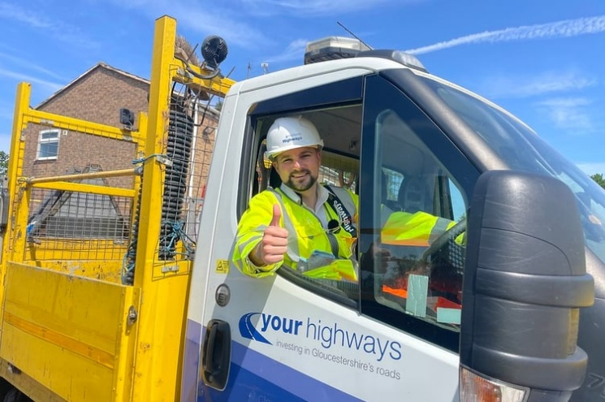
We committed an extra £15 million into highways in our budget, the biggest county cash boost for generations.
This has allowed us to get as many highways’ teams out as possible, battling potholes and resurfacing roads.
We have fixed a whopping 47,000 potholes since taking power and are resurfacing a further 55 roads this spring alone.
We launched our clean sweep initiative in July that tackles road signs and equipment that get left behind by contractors after jobs are finished. It also gets contractors to make sure signage faces the right way, clear weeds from gullies and sweep up debris while they’re out and about.
Sustainable Transport & Strategic Highways
We are committed to road safety
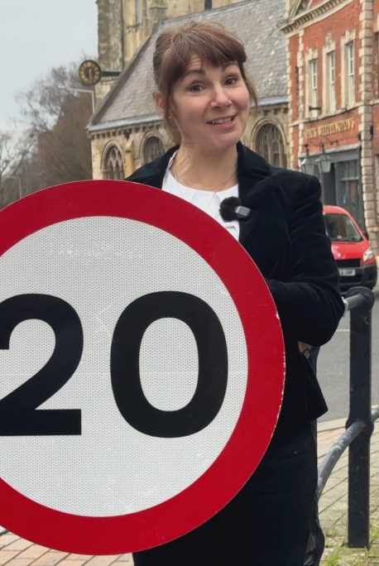
We have begun the roll out of 20mph zones and other speed reductions; these have been planned both where the community wants them but also where they are most likely to tackle the devastating amount of road traffic casualties our county faces.
We have facilitated the roll out of the cycleway. This provides a safer space for cyclists to use, promoting greener, healthier living and putting infrastructure first.
We are improving sustainable and public transport
We have facilitated the launch of two large electric bus fleets by working with both Stagecoach and Pulham’s.
We have expanded the reach of the Robin, our on-demand bus service, to further rural areas.
We have created a map of the entire county’s bus routes to make it easier for residents to plan journeys by public transport.

Business, Economic Development, Planning and Infrastructure
We are working hard to boost our economy
We launched our new Digital Strategy with a focus on innovation, inclusion and infrastructure.
- We are working with infrastructure providers to ensure that we have best-in-class mobile and broadband infrastructure reaching all corners of our county.
- We are ensuring that all our residents have access to technology and are confident using it.
- And are bringing together leading digital thinkers in a Digital Innovation Advisory Board.
We are driving the rollout of Business Improvement Districts across the county.
We set up a multi-agency working group for the Forest Of Dean to tackle deprivation.
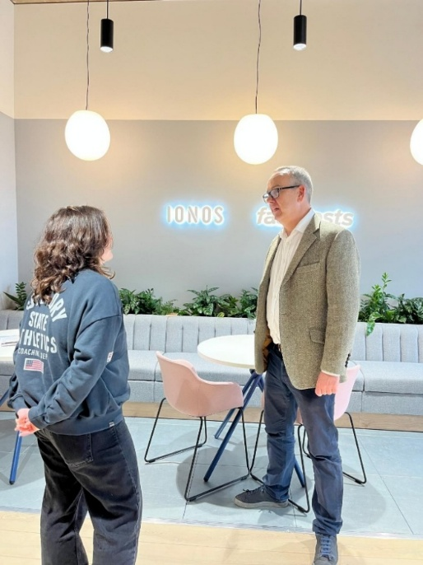
We lobbied hard to receive additional funding for the M5 Junction 10 improvements scheme. This is now underway and we are incredibly excited about the infrastructure upgrade that will unlock homes, jobs and investment for our county.
We launched our Gloucestershire Business Board to bridge the gap between leading local businesses and the Council. This enables us to fully understand their needs and gives them a clear role in holding us to account, while we work hand in hand to deliver our economic strategy.
We have also launched a full review into how we work with our prominent farming and agriculture industry, alongside a Made in Gloucestershire review. This will help us optimise our support for farmers and small food and drink producers.
We are working hard to support existing local businesses and encourage investment into the county, with a focus not just on the towns, but our expansive rural communities as well.

Children’s Services & Education
We’re committed to giving young people the best start in life.
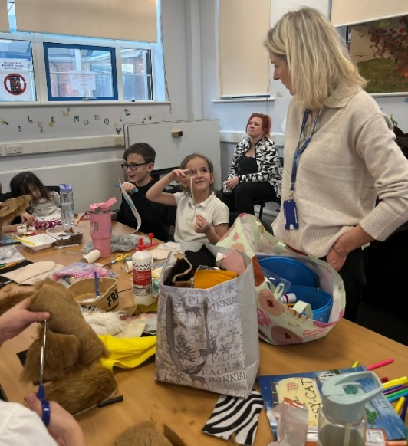
After 16 years of poor Ofsted ratings under the previous Tory administration, Children’s Services is now rated as ‘Good with outstanding features.’ A huge achievement in such a short time in administration.
We launched our Family Hubs network - welcoming, one-stop spaces designed to bring families together and make sure no one ever feels they have to navigate parenthood alone.
Providing everything from advice, fun activities, support, or simply a friendly face who listens, our Family Hubs are here for our communities and children, every step of the way.
We’ve extended the Holiday Activities and Food (HAF) programme for another three years. This provides holiday activities and healthy meals as well as support for families, including advice on food, health, and wellbeing.
We extended this so its accessible to ALL families not just those on low income.
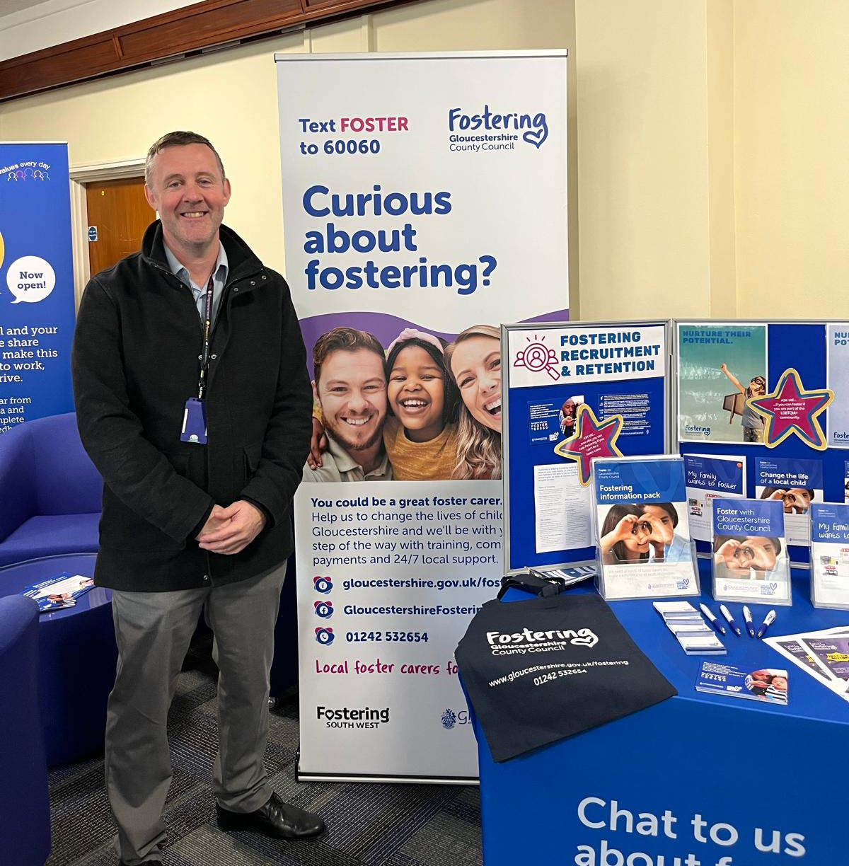
We are in the process of creating 3 new special schools, so that children with complex needs can access the education they deserve.
We welcomed the SEND White Paper and are currently reviewing how it will impact us, ensuring we can continue to provide the best possible support for ALL children of this county.
Together, we’re building stronger families, stronger communities, and a brighter future for every young person.

Adults' Support & Independence
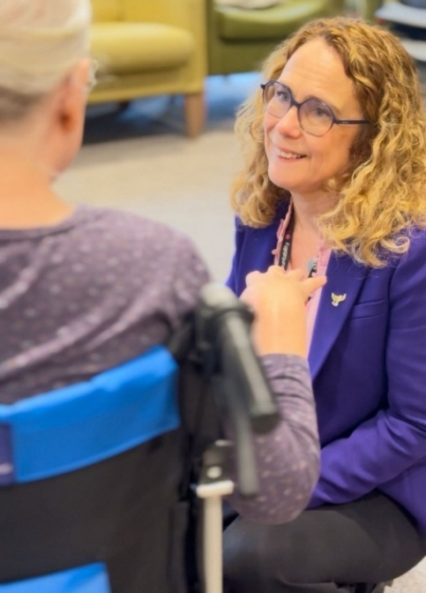
Creating a care system that cares
We inherited an Adult social care service rated 'requires improvement' from the previous Tory administration and have been working tirelessly to transform this.
We want all vulnerable adults to live in a place they call home, as independently as possible, for as long as possible, living “gloriously ordinary” lives. We are investing in technology that helps to keep people safe at home and building three brand new care homes across the county so that people can stay close to their loved ones if they do need residential care. We are welcoming vital staff members, including Occupational Therapists and mental health social workers, back into our team so that we can work together to help people maintain or regain their independence.
Later this year, we will launch our brand-new Gloucestershire Care Academy, a virtual space providing easy access to accredited training and qualifications for all carers, paid and unpaid. Caring is an incredibly demanding role, and we want all carers in Gloucestershire to know that they are valued and appreciated, supported to give the best possible care to the people they look after, and able to get help themselves when they need it.

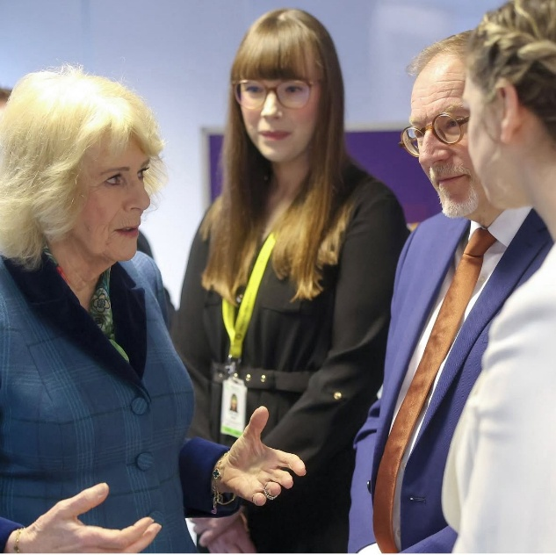
Public Health, Communities & Fire
We are protecting and serving our residents
We launched our new Domestic Abuse Strategy. We are investing in prevention, protection, and partnership to ensure every resident can live free from fear and harm. The launch of this was honoured by a visit from Her Majesty The Queen.
We are investing in our Fire and Rescue Service, ensuring the best team and equipment is available for our communities in times of need, including investing in ten new fire engines.
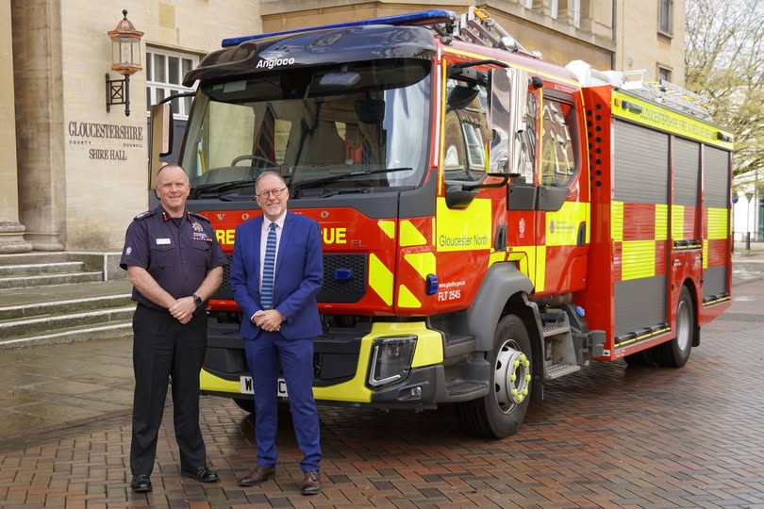
We are updating our libraries, making them modern, inclusive and accessible. We worked with the University of Gloucestershire to open the new Gloucester Library with a host of exciting features including a dedicated, self-contained Lab space, ideal for workshops, creative sessions and community events.
We launched our Grassroots Neighbourhood Fund, providing £1.1 million in community funding for initiatives that seek to make a positive impact on health and wellbeing and our local communities.

Nature, Climate & Waste Reduction
Our commitment to great green Gloucestershire
We launched our Local Nature Recovery Strategy (LNRS), a county-wide spatial plan designed to guide nature recovery, identifying priority habitats, and supporting biodiversity enhancement across Gloucestershire.
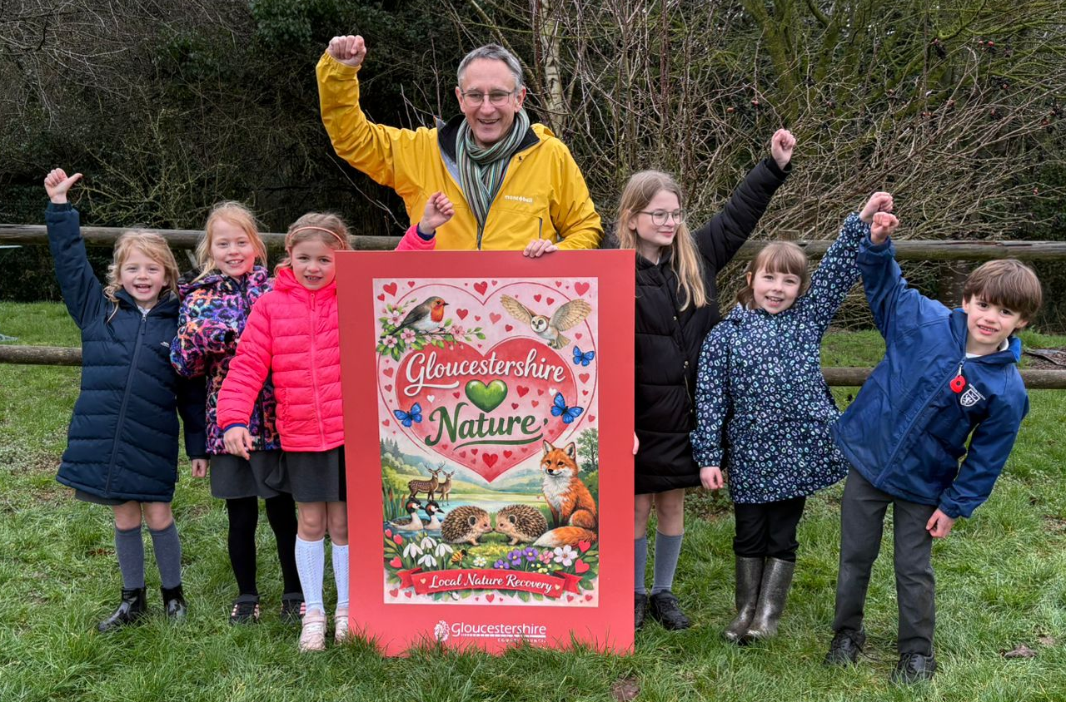
We’ve committed £3.9m over the next four years to upgrade three more of our household recycling centres, making them safer, more efficient and lower carbon.
Launched a £100,000 fund for natural flood management schemes in local communities and are working the Environment Agency and regional partners to support natural flood management at landscape scale across the county
We’ve relaunched a £100,000 fund for local climate action projects and committed to work with our suppliers and contractors to properly measure and tackle the 73% of our carbon footprint that comes from bought-in goods and services
We’ve championed community composting, the reduction of food waste and the re-use and recycling of everything from electrical equipment to coffee pods while converting our waste haulage fleet to run on sustainable vegetable oil.
Finally, we’ve just published our sixth annual climate change report, and the results show our emissions are continuing to fall, a clear sign of our ongoing commitment to Net Zero.

Cllr Gill Moseley
gill.moseley@gloucestershire.gov.uk
01531 820826

